Lab 2: AXIS I: Role and Use of Open-Source Tools in AI Part 2

Exercice 01 :

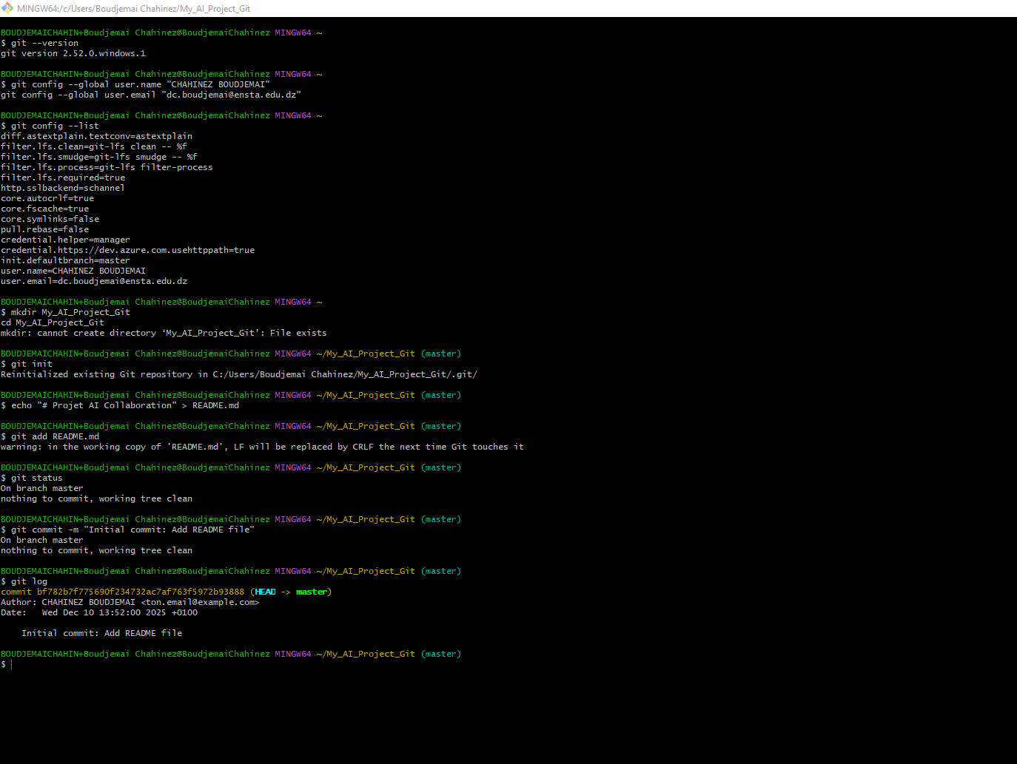

Exercice 02 :
